**How to use**

1. git clone <https://github.com/Alissa-lim/IOC_Validator.git>
2. cd IOC_Validator
3. pip install requirements.txt
4. python IOC_Validator.py
   1. 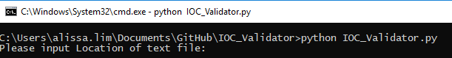
5. Input full path of text file containing URLs like this:
   1. 
6. Program will run through each URL in the list and print out “Reading completed” when done:
   1. 
7. View content of each IOCs found in each report by the folder name:
   1. 
   2. Inside each folder is an IOCs folder:
   3. 
   4. Inside the IOCs folder is each different type of IOCs
   5. 